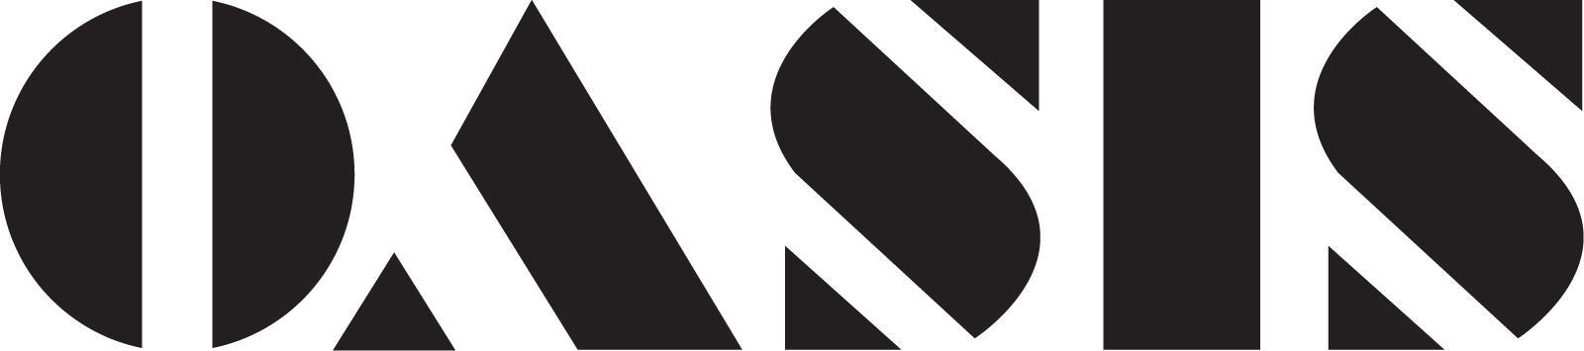
298 Eleventh Street, San Francisco, CA 94103 – sfoasis.com

FOR IMMEDIATE RELEASE, January, 2019
Media Contact: Sailor Galaviz - sailor@sfoasis.com – 559-246-5787 (please don’t publish)

For press materials and hi-res color press photos, visit:
www.sfoasispress.com/startrek

D’Arcy Drollinger presents:
Star Trek Live! “The Naked Time”
August 29 – September 21, 2019- (Thursday-Saturday at 7:00 pm)
Limited Engagement – Only 12 Performances!
at Oasis in San Francisco
www.sfoasis.com

Back by popular demand, the Drag Kings take over the stage at Oasis in D’Arcy Drollinger's Star Trek Live! Opening Thursday August 29th and running Thursday-Saturday through September 21st at Oasis, 298 11th Street @ Folsom.

Starring some of San Francisco's best comedic performers, this drag parody of the ground-breaking television classic will send up a fan-favorite episode of the original series, “The Naked Time”, in which a strange affliction effects the crew of the Enterprise causing them to act as though they are drunk, resulting in the lose of control of the ship. Featuring Leigh Crow, the world's only female William Shatner impersonator, as Captain Kirk. The cast also includes Laurie Bushman (Joe Tormolen), Anne Norland (Spock), Ammo Eisu (Sulu), Zelda Koznofski (Bones), Carol Walker (Riley), Mercedez Munro (Uhura), Dene Larson (Nurse Chapel). Costumes by Ruby Vixen. Set design by Sarah Phykitt, Lighting design by Sophia Craven. Directed by D'Arcy Drollinger and Sailor Galaviz.

Calendar Editors:

WHAT: Star Trek Live! “The Naked Time”

WHEN: August 29 – September 21, 2019- (Thursdays-Saturdays at 7:00 pm)
Limited Engagement – Only 12 Performances!

TIX: Tickets are $27.50 - $50
Tickets available at http://sfoasis.com
Advance tickets recommended, as seating is very limited.

VENUE: Oasis, 298 Eleventh St. @Folsom St.), SF CA 94103

WEB PAGE: http://www.sfoasis.com

PRESS INFO: For press materials and hi-res color press photos, visit: www.sfoasispress.com/startrek

OASIS is wheelchair accessible.

###

